FLEXIBILITY: 2017 and 2018 Legislative sessions enacted flexibility for use of what would otherwise be categorical funding. Accessing this flexibility is regulated, with all three requiring a school board resolution:

- HF 564 Categorical Flexibility from 2017 allowed transfer from general fund to student activity fund for protective equipment retroactive to July 1, 2016 (p. 6)

- HF 565 Flex Fund Account 2017 set up a flexibility fund to receive transfers from categorical fund balances in professional development, home school assistance, preschool and a discontinued fund. Although enacted in the 2017 Session, this ability to dedicate the funds to another purpose is effect July 1, 2017 (p. 2)

- HF 2441 Flexibility 2018 allows student activity fund transfer for refurbished (in addition to new) athletic equipment and allows transfer of child care fund balance to general fund (p. 5)

This table lists the requirements for board action/resolution in the various bills passed over the last two years and copies of sample resolutions for each purpose follow on pages 2-6:

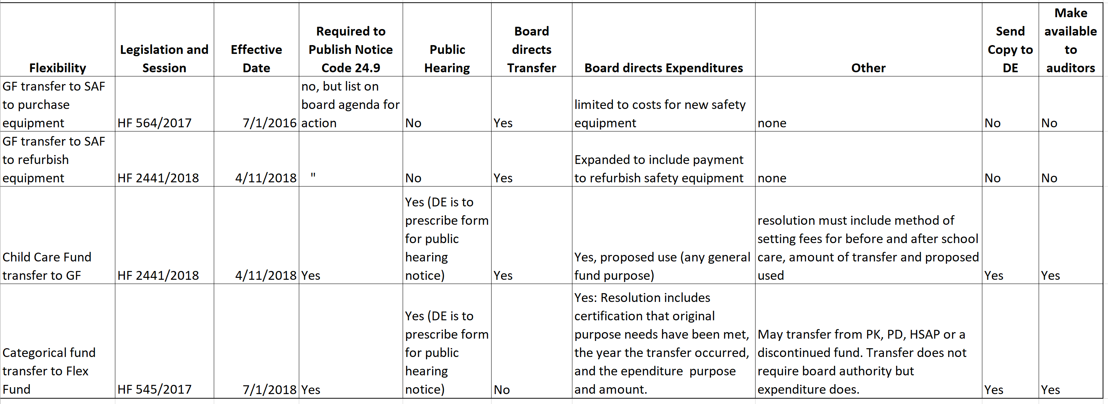

margaret@iowaschoolfinance.com (515)201-3755
Date _________________________
A RESOLUTION DIRECTING EXPENDITURES OF THE SCHOOL FLEXIBILITY FUND
The Superintendent of the _______________ Community School District presents the following Resolution for adoption:
WHEREAS, HF 565 School Flexibility Fund, was established in the 2017 Legislative Session to provide local control and flexibility regarding the use of ending balances in certain categorical funds effective July 1, 2018; and
WHEREAS, the _______________ Community School Board of Directors conducted a public hearing on _______________ as required by Iowa Code 298A.2(d), using the form of public hearing prescribed by the Iowa Department of Education, which was published in the same manner as required in Iowa Code 24.9, to provide adequate notice to stakeholders and transparency of intended board action; and
WHEREAS, the __________________ Community School District has fulfilled the needs intended to be met by the following categorical funds, as hereby certified by the Board of Directors, and that the statutory requirements for the following original sources of funds have been met, have been repealed, or are no longer in effect as noted below (check all that apply, enter fix year from which funds are transferred and delete those not being used):
- Statewide four-year old Preschool Program under Iowa Code 256C was provided to students in the _______________fiscal year from which the ending balance is carried forward, and preschool programming was provided to all eligible students for whom a timely application for enrollment was submitted, and a balance remains unencumbered and unobligated at the close of FY ______________
- Professional Development funds received under Iowa Code 257.10 (10) were used to meet all statutory requirements of Iowa Code 284 and a balance remains unencumbered and unobligated at the close of FY ______________
- Home School Assistance Program under Iowa Code 299A.12 statutory requirements for all purposes listed in 299A.12 (2) have been met and funding for all lawful requests for services and materials from parents or guardians of students eligible to access the program has been provided and a balance remains unencumbered and unobligated at the close of FY _____________
- ______________________ (insert name of a fund that is discontinued for which the district still has an unobligated ending balance, such as the Market Factor Pay fund) which is no longer required to be expended for those purposes as the fund has been discontinued, and a balance remains unencumbered and unobligated at the close of FY ______________
WHEREAS, the __________________ Community School District has transferred the following funds authorized pursuant to HF 565 into the School Flexibility Fund (check all that apply and enter fund balance total, the amount that was transferred and the fiscal year from which the transfer of such funds to the flex account occurred and delete those not being used):
- Statewide four-year old Preschool Program under Iowa Code 256C ending balance of $ ____________________ of which $_________________ was transferred to the Flexibility Fund from FY _________________
- Professional Development funds received under Iowa Code 257.10 (10) ending balance of $ ____________________ of which $_________________ was transferred to the Flexibility Fund from FY _________________
- Home School Assistance Program under Iowa Code 299A.12 ending balance of $ ____________________ of which $_________________ was transferred to the Flexibility Fund from FY _________________
- ______________________ (insert name of a fund that is discontinued for which the district still has an unobligated ending balance, such as the Market Factor Pay fund) which is no longer required to be expended for those purposes as the fund has been discontinued ending balance of $ ____________________ of which $_________________ was transferred to the Flexibility Fund from FY _________________
WHEREAS, the Board of Directors of the ________________ Community School District has determined the needs of students would be better served by the flexible expenditure of these funds during the budget year beginning in or after the calendar year in which the transfer to the flexibility fund occurs, for the following purposes: (select all that apply and designate amount for each purpose and delete those not being used)
- Start-up costs for an approved local program under the statewide preschool program for four-year-old children under Iowa Code 256C $ ___________________
- Professional development requirements under Iowa Code 284 $_______________
- Home school assistance program under Iowa Code 299A.12 $ ____________________
- At-risk pupils programs, alternative programs and alternative school programs, and returning dropout and dropout prevention programs under Iowa Code 257.40 $_________________
- Gifted and Talented children programs under Iowa Code 257.46 $___________________
- Unpaid Student Meal account in the school nutrition fund under Iowa Code 283A.11(6) to pay individual student meal debt $ ________________________________
- Any school district general fund purpose (state general fund purpose for which the funds will be used, such as staff, programs, transportation, curriculum, utilities, or any other general fund purpose) $______________________
Now, therefore be it RESOLVED, that the Board of Directors of the _______________ Community School District, acknowledges the transfer of such funds to the Flexibility Fund within the General Fund, and requires expenditures accordingly for those purposes stated above, total amount of $______________ to be available for expenditure effective for the _______________ Fiscal Year.
RESOLVED, that the Superintendent is directed to include the information concerning such expenditure in the budget certified in accordance with Iowa Code 24; and be it further
RESOLVED, that the Superintendent is directed to provide a copy of this Resolution to the Iowa Department of Education as they prescribe and make such Resolution available for any audit of the district performed under chapter 11.
Resolution approved, _____________________________(date) by the _________________ board of directors:
(list school board members and aye or nay vote of each)

Signed,

___________________________
Chair – Board of Directors
____________________ Community School District
__________________
Superintendent
__________________ Community School District

Date _________________________
RESOLUTION TO TRANSFER EXCESS CHILD CARE FUNDS TO THE GENERAL FUND
The Superintendent of the _______________ Community School District presents the following Resolution for adoption:
WHEREAS, HF 2441 School Flexibility, effective April 11, 2018, provides flexibility for use of ending fund balances in the child care fund under 298A.12; and
WHEREAS, the _______________ Community School Board of Directors conducted a public hearing on _______________ as required by Iowa Code 298A.12(2), using the form prescribed by the Iowa Department of Education, published in the same manner as required in Iowa Code 24.9, to provide notice to stakeholders and transparency of intended board action; and
WHEREAS, the __________________ Community School District has fulfilled the needs intended to be met by the collection of fees for provision of before and after school care and has a balance remaining and unexpended in the child care fund; and,
WHEREAS, the fee structure for parent payment for before and after school care is determined by __________________________________ (state any important details, such as, in collaboration with other providers in our community so as not to undercut their services and create a loss of capacity available for before and after school care for students.) and
WHEREAS, the Board of Directors of the ________________ Community School District has determined the needs of students would be better served by the flexible expenditure of these funds for the purpose of ___________________________________________(state intended expenditure of transferred funds which could state any school district general fund purpose such for which the funds will be used, such as staff, programs, transportation, curriculum, utilities, or any other general fund purpose), Now, therefore be it
RESOLVED, the Board of Directors of the ____________ Community School District authorizes the transfer of such remaining and unencumbered funds to the General Fund, and requires expenditures accordingly for those purposes stated above, total amount of $______________ to be available for expenditure effective for the _______________ Fiscal Year.
RESOLVED, that the Superintendent is directed to provide a copy of this Resolution to the Iowa Department of Education as they prescribe and make such Resolution available for any audit of the district performed under chapter 11.
Resolution approved, _____________________________(date) by the _________________ board of directors:
(list school board members and aye or nay vote of each)
Signed,
___________________________, Chair – Board of Directors
__________________ Superintendent, _________________ Community School District
RESOLUTION AUTHORIZING TRANSFER OF GENERAL FUND TO STUDENT ACTIVITIES FUND FOR PROTECTIVE GEAR
Whereas participation in athletic and other school extracurricular activities furthers the skills, development, character and growth of our students, and
Whereas safety of our student athletes is of paramount importance to the district, and
Whereas student activity funds are insufficient to cover the costs of refurbishing or purchasing protective and safety gear required by the Athletic Associations for students participating in those activities, and
Whereas the Iowa Legislature authorizes school boards to use school general funds for these purposes consistent with the enactment of HF 564 during the 2017 Legislative Session, effective for the school year beginning July 1, 2016, and subsequent school years,
BE IT THEREFORE RESOLVED:
That the Board of Directors of the _____________ Community School District approves the transfer of $_______________ from the general fund to the student activity fund for expenditures that occurred between ______________________________(eg., July 1, 2017 and June 30, 2018) for protective and safety gear required for athletic competition.
Resolution approved, _____________________________(date) by the _________________ board of directors:
(list school board members and aye or nay vote of each)

Signed,

___________________________
Chair – Board of Directors
____________________ Community School District
__________________
Superintendent
__________________ Community School District

