For the first time in Iowa history, writing will be authentically assessed on the state test, starting next school year in the spring of 2019. As with any skill in which students must become proficient, writing takes practice and feedback, and a lot of it. It is also a gateway skill to success in college or career in today’s information age.

Learn more about how WriteToLearn can help your staff and students succeed, about the new state assessment and other legislative changes, including funding and flexibility in so many areas, available to schools based on the action of the 2017 and 2018 Legislative Sessions. Other topics from school finance to collective bargaining changes one year later are on the agenda. Register for the ISFIS annual conference, June 15, at the FFA Enrichment Center in Ankeny or learn more here.

The ISFIS program WriteToLearn™ (WTL), which electronically scores student writing in grades 4-12, can provide that practice and instant feedback, so that teachers can assign adequate practice in writing and not be crushed by the burden of scoring it all. WriteToLearn provides prompts for narrative, expository, and argumentative essay writing across the curriculum, as well as text for students to summarize that aligns to social studies and science units. Since the Core standards expect more writing integrated into science and social studies, WTL is an excellent tool to assist social studies and science teachers meet the Core expectations. Additionally, through useful and easy-to-access and read reports, WriteToLearn™ can help teachers as they plan instruction to meet student need.

Below is language from the bill, HF 2235, signed by the Governor on March 28. The entire text is found here. Highlights following:
- Iowa’s summative assessment will be developed by Iowa Testing and administered by their designee.
- Assessment will begin during the school year of 2018-19 (next school year).
- “…(A)ll students enrolled in school districts in grades three through eleven (will) be administered an assessment in mathematics and English language arts, including reading and writing, during the last quarter of the school year and all students enrolled in school districts in grades five, eight, and ten (will) be administered an assessment in science during the last quarter of the school year.”
- “….(T)he assessment, at a minimum, (will) assess the core academic indicators (noted above), be aligned with the Iowa common core standards in both content and rigor; accurately describe student achievement and growth for purposes of the school, the school district, and state accountability systems; provide valid, reliable, and fair measures of student progress toward college or career readiness; and meet the summative assessment requirements of the federal Every Student Succeeds Act…”
- “… (The) assessments … (will be) available for administration in both paper-and-pencil and computer-based formats and include assessments in mathematics, science, and English language arts, including reading and writing.”
- “…(T)he assessment (will) be peer-reviewed by an independent, third-party evaluator to determine that the assessment is aligned with the Iowa core academic standards, provides a measurement of student growth and student proficiency, and meets the summative assessment requirements of the federal Every Student Succeeds Act…. The assessment developed by the Iowa testing service within the university of Iowa college of education shall make any necessary adjustments as determined by the peer review.”

Teaching Secondary Students to Write, put together by the What Works Clearinghouse, defines effective writing like this.
Effective writing:
- “Achieves the writer’s goals. These goals can be set by the writer or teacher, or through collaboration between the writer, teacher, and/or peers.”
- “Is appropriate for the intended audience and context. For example, a persuasive text written for a school newspaper may look different than one written for an online forum.”
- “Presents ideas in a way that clearly communicates the writer’s intended meaning and content. The writer’s ideas are well-organized and clear to the reader and expressed effectively.”
- “Elicits the intended response from the reader. For example, a persuasive text compels the reader to take action, whereas a mystery novel elicits feelings of suspense or surprise from the reader.”

The Clearinghouse also makes these recommendations related to writing instruction:
- Recommendation 1. “Explicitly teach appropriate writing strategies using a Model-Practice-Reflect instructional cycle.”
- Recommendation 2. “Integrate writing and reading to emphasize key writing features.” The essay prompts from WriteToLearn™ are well-written and elicit thorough answers. Some of the prompts offer text, which students are asked to read, and then asked to develop written responses from that text. Additionally, there are essay prompts that ask students to reflect on elements found in various pieces of expository, narrative, and argumentative text. Also, WriteToLearn™ offers summary texts to read and summarize; certainly, WTL integrates reading and writing, as all effective reading and writing programs do.
- Recommendation 3. “Use assessments of student writing to inform instruction and feedback.” WriteToLearn™ supports this recommendation well for both students and teachers. Reports immediately generated from student writing are aligned to either the 6 Traits of Writing or the Iowa Core; they help students to reflect on and analyze their own writing, they assist teachers in planning lessons and provide excellent information related to where to go next in instruction.)

WriteToLearn™ Prompts

WriteToLearn Prompt and Data Aligned to the Core (data was created for illustration purposes only, using fictitious students)
This 7th grade prompt is the basis for the data that follows. The CCR 5 stands for College and Career Ready Standards. Please note how similarly the language used in this prompt is aligned to the language used in the Core. WTL also has alignment to the 6 Traits of Writing. Both alignments offer useful data for moving student performance in writing forward.

School Vending Machines – CCR 5
Read the following statement: School vending machines should sell only healthy snacks and drinks. Do you agree or disagree with this statement?
Write an argument:
- Give a clear position.
- Explain your position with clear reasons.
- Support your reasons with relevant facts and details.

Following is the Overview Report developed from writing to the prompt above. From this report (for this prompt), teachers get help analyzing student performance on elements derived from the core, which are called the College and Career Ready alignment:
- Overall Score
- Task and Focus
- Development of Ideas
- Organization
- Language and Style, and
- Conventions.

The columns and rows to the far right show how much time each student has spent on the prompt, how many drafts they have written, the word count, and spelling and grammatical errors. If the teacher looks vertically, the report shows how the class as a whole is doing on each element, so teachers can plan instruction.

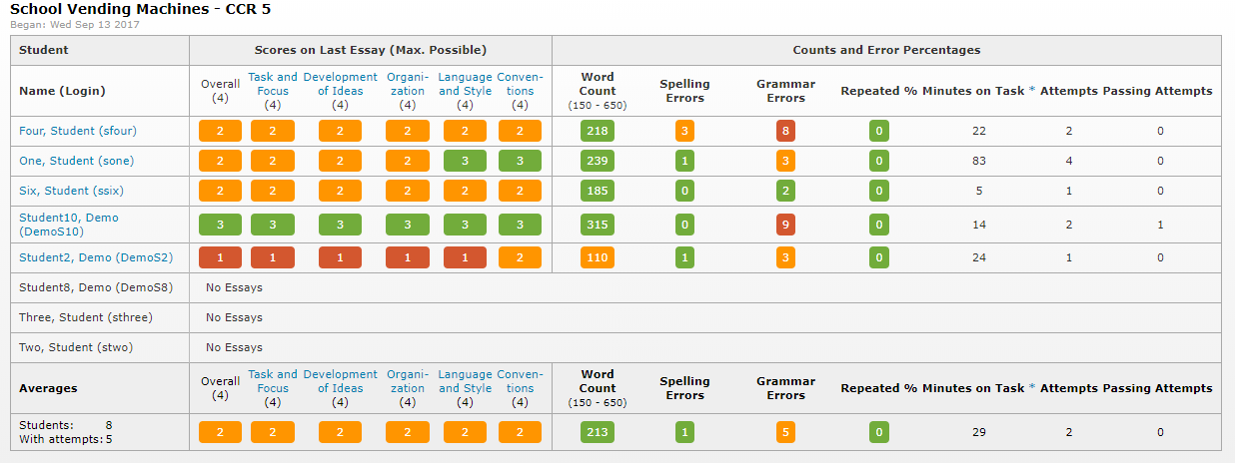

Time for Writing

Another important element of writing instruction is providing adequate time and various tasks for which students write. Jennifer Knight, Ph.D. from the Iowa Reading Research Center notes in her article, “Developing Writers in the Classroom: Daily Writing Time and Multipurpose Writing.”

If students are not given time to write, they will never develop writing habits and skills. Think about how you learned to ride a bike. If you only looked at your bike but never got on it, or sat
on it but never peddled, you would not have learned to ride. It is only routine practice that allows you to develop the skills necessary to ride on your own without support. The same is true with writing. Without practice, students will never develop the skills and strategies necessary to write on their own and writing likely will become a difficult and undesirable task.

WriteToLearn™ offers students writing practice with immediate feedback. If a pianist hopes to have exemplary piano skills, he must practice extensively and get feedback from an expert teacher. If a basketball player hopes for a college scholarship, she must practice repeatedly with feedback from her coach. If writers wish to become proficient and higher, they must practice regularly and receive feedback on their practice writing. Teachers can assign extensive practice, but it’s impossible to provide immediate feedback for multiple learners, even in small classes, let alone the class sizes many teachers face with current budget pressures. This is the advantage of the ISFIS electronic writing tool, WriteToLearn™. Students receive instant feedback. Teachers are offered wonderful reports for planning instruction. Teachers are relieved of the some of the overwhelming responsibility of scoring all of the practice drafts but may still weigh in on specifics. For example, they may focus feedback on the main thing, such as siting evidence, rather that providing all of the grammatical and spelling corrections. WTL allows teachers to assign more writing and still have a life!

We invite you to contact Susie Olesen (susie@iowaschoolfinance.com or 641-745-5284) at ISFIS for an on-site or on-line demonstration of WriteToLearn™.

