Portfolio Report: Accessing Student Work
- Log into your teacher account.
- In the Reports column, click on Portfolio.
- When the page opens, drop down to the class in which the assignment was given. Then drop down to the assignment you wish to read. Once you have done these first two steps, a third drop down will appear and you should click on the student whose work you wish to see.
- All of the drafts related to this work will appear on the next screen and look something like this.

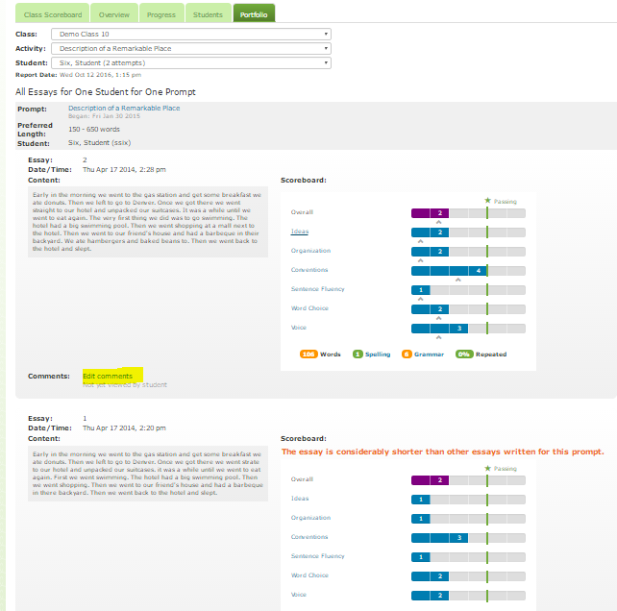

- On the previous snip, note in the second draft to the right of Comments there is a yellow highlighted command entitled “Edit Comments.” Click on Edit Comments and a screen will pop-up with that draft. This screen enables you to make comments on the draft.

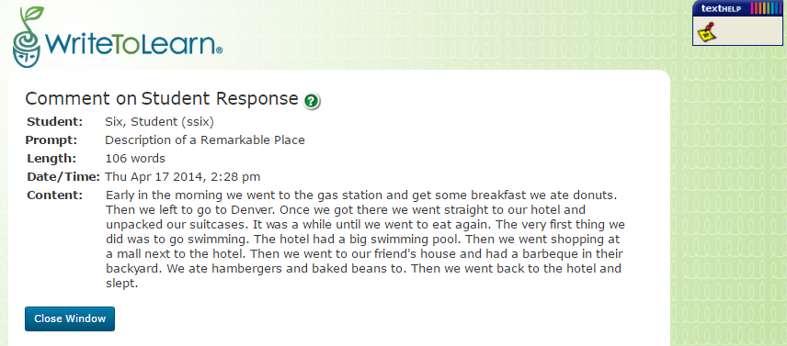

- Click on the yellow stickie note in the right hand corner. Then click in the draft in a spot you want to comment. An electronic sticky note will appear and you can make comments on the student writing. Save the note at the bottom. When the student gets into his account, he/she will see your comment.

