Prompt Writing
Prompts that you write will be given an overall score. The reason for that is that they have never been hand scored by the expert scorers at Pearson. Still, the overall score will provide an idea of how well the essay is written and also, of course, all of the grammar and spelling information.
Also, all teacher written prompts are identified as essays and will be scored using an essay rubric.
- Log into their teacher account.
- Under the Tool column, click on Prompts.
- At the top of the page you will see this. Click on Prompt Writing Guidelines (the arrow points to it.
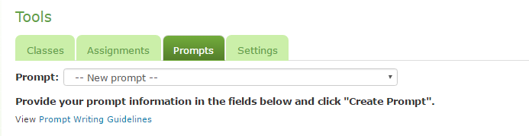
- Read the guidelines – they will provide excellent information for the teachers to consider as they write effective prompts.
- You need to fill in the boxes behind Prompt and Title and drop down the grade level and essay type in which you are working.
- When you are finished, click on Create Prompt.
- Then go to assignments at the top of the page.
- Select the class in which you want the prompt to be assigned and that class and they assignments that have already been assigned to them will come up.
- Click on Select Activities and three boxes with drop down possibilities will come up. Drop down to Essay, the grade level at which you want the prompt to score, and select user authored for the third drop down. See example below.
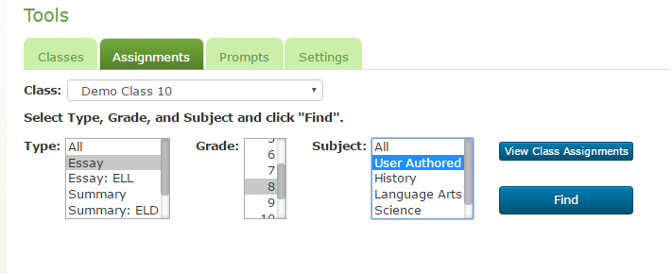
- Click on Find. All of the user authored prompts from your school will come up. Put a check mark in front of the one you wish to assign. A box will pop up that says, “Saving assignment…” and will go away quickly.
- Click on “View Class Assignments” and a page of all the assignments made to the class will appear. You can check to see if your assignment has been added to the list of assignments.

