Directions for Parents Supporting Their Children Using WriteToLearn™
Student Name_________________________________________
WriteToLearn Username ________________________________
WriteToLearn Password _________________________________
Directions for Accessing WriteToLearn™ at Home.
- Log onto your computer. Connect to the Internet.
- Go to your student login site. Here is the student login link for your school district:
_______________________________
- When you open up the page, it will look like this. Your school name will appear in the yellow highlighted line. Enter the username and password from the top of this page into the correct boxes.

- Click on Let’s Go! to arrive at a page with the student assignments. Students may work on any of that are listed as long as they have tries left, but be sure to read information from the child’s teacher in case the teacher suggests a specific activity. There are two kinds of writing activities available, essay and summary. Here are some examples of assignments that may show up, starting with an essay aligned to the College and Career Reading Standards.

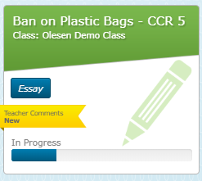
The name of this essay assignment (and others) is at the very top of the assignment box, and the class from which it is assigned is directly below the name of the prompt. CCR 5 stands for the five college and career ready elements used on the ISASPs. If the prompt is not followed by CCR-5, it is aligned to the 6-Traits of Writing, another very useful writing rubric. Both are scored by the same Pearson scoring engine, but use the language of each specific rubric when providing feedback.
The yellow tag indicates the teacher has made a comment on the student’s writing. Click on the link to see the comment.

This is what will come up after clicking on the link to see teacher feedback. Click on the electronic sticky note toward the bottom of the essay and feedback will appear that the teacher has entered into the program.
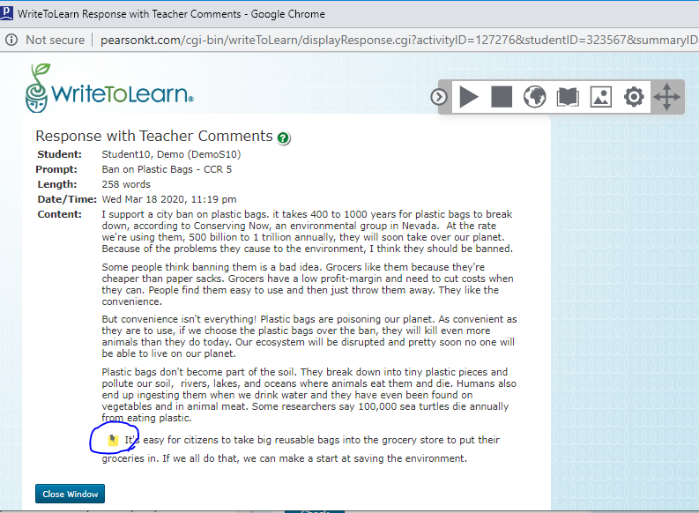
Click on the electronic sticky note, and teacher feedback will appear on the page.
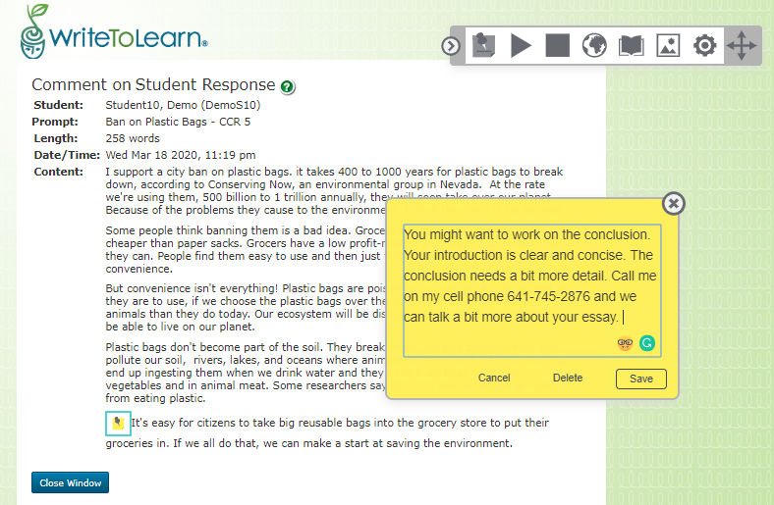

Here is the view of other sorts of assignments, an essay aligned to the 6 Traits of Writing and a summary activity.
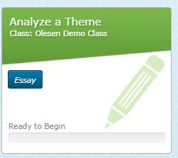
This summary activity asks HS students to write a summary of the Declaration of Independence. By clicking on the blue View Summary link, students will see the text of the Declaration to read. When finished reading, students click a green Write Summary link on the right side of the page, which will take them to the site where the student writes. This student has used up all of the tries available and can’t write on this activity anymore. Some summary activities include vocabulary exercises that must be completed before the reading or writing can be started. More about that in the summary writing directions.

This is an essay prompt and the scoring on this assignment aligns to the 6-Traits of Writing. Students will know that because the CCR-5 is not listed in the icon associated with the prompt. Once again, the prompts are scored by the same scoring engine, which adjusts the feedback to the language of each individual writing framework. The newer prompts use the CCR-5, but both alignments provide excellent feedback to students and helpful instructional information to teachers.
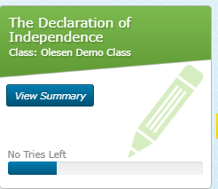

Student Essay Writing
Once students click into an essay activity, this is what they will see when they start a new essay activity. First we’ll start with the upper right corner of the page.
In the right hand corner of the page, students can choose in which language they would prefer to receive directions, English, Spanish, or simplified Mandarin Chinese. Notice the drop down menu with English. Everything but the directions will always be in English. So, if students need directions other than English, they are available in the drop down menu.
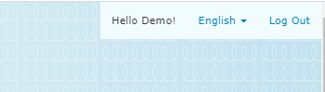
Next is the rest of the page. Everything in red is a direction.
These questions below help students get started and think through the essay as they write.
Below is the prompt to which the student will write.

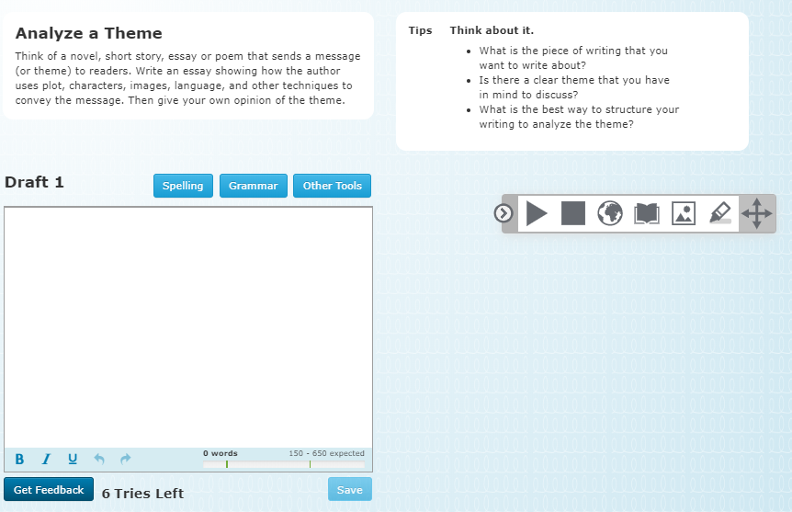Once you have written your initial draft, you click on Feedback in the blue box in the bottom left hand corner. The scoring engine will have a look and your scores will populate on the right side of the page. See below.
This is the box in which the student writes.
At the bottom of this box, notice “6 Tries Left.” That means the teacher has provided 6 chances to edit the writing. That number cannot be changed once it has been assigned.
Notice the expected word count at the bottom right. As the student writes, the number of words will populate at the bottom.
Click on Get Feedback once each draft is completed..
Above is a tool bar. To hear a word or sentence, highlight it and click on the arrow directly above this box. A computer-generated voice will read the highlighted word or sentence. To stop the sound, click on the box to the right of the arrow.
To translate directions into Spanish or simplified Mandarin Chinese, click on the world icon. Choose the language preferred.
To access a dictionary definition, click on the book. A picture dictionary is also available for some words to the right of the book.
To highlight text with color, first select preferred text with the cursor. Then click on the marker and choose the prefered color and the highlighted content will turn the color selected
The vane can be used to move the tool bar around/
Click on any of the blue buttons below for more help. There is no auto correct. Under “Other Tools” the student will find help with how to write the essay assigned.

Below is an example of a student who has written a first draft. Notice at the bottom of this draft, the student has 5 tries left and has written 258 words. The scoring this student earned is on the right. The student is proficient Overall, as well as in Task and Focus, Language and Style, and Conventions. The student can click on the green Explore buttons and orange Improve buttons behind the writing elements on the far right and get helpful information about each element and some things you might consider in subsequent drafts. The student is finished when the score for Overall and the traits is 4 (or 6 in some rubrics) or have run out of tries.
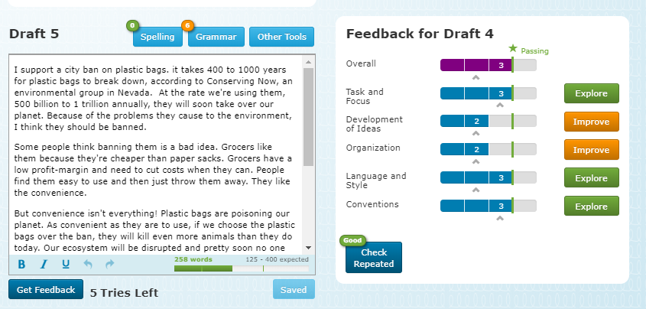
Remember this is a writing practice tool. It’s not perfect, but it’s a great way to practice writing. Learning to write takes a lot of practice, just like learning math facts, playing the piano, becoming a good reader, or becoming an excellent soccer player. Scoring writing is the activity teachers do that uses up enormous amounts of time. One teacher said she spends 20 hours weekly outside of school scoring her high school students’ writing. This program helps teachers with that overwhelming, time-consuming task.

Student Summary Writing
When you click on the word Summary two or three choices will come up: Vocabulary, Reading, and Summary. In this lesson, all three come up. Please start with Vocabulary.
Click on Begin on the next screen.
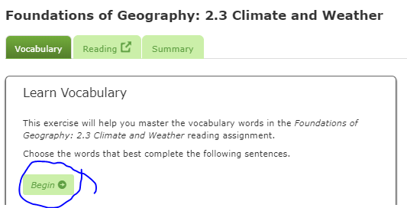
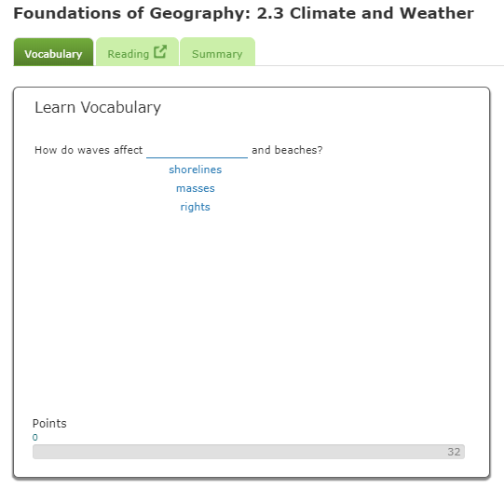
If there is a vocabulary exercise accompanying the summary activity, the student must complete that before moving on. Some don’t have the vocabulary exercise and the student goes directly to the reading.
The students read the question and choose the answer they think is accurate.
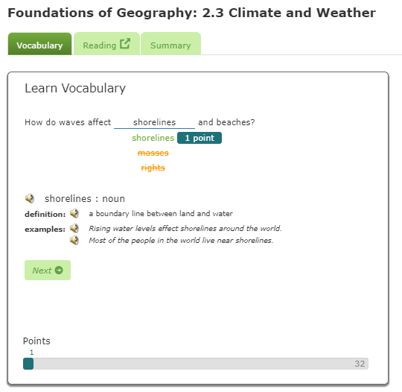
This student tried three times before getting the correct answer, so she only received one point. The definition pops up after two tries. The student then goes to next. When the student is finished it will invite that student to read the essay and when that task is finished to write the essay.
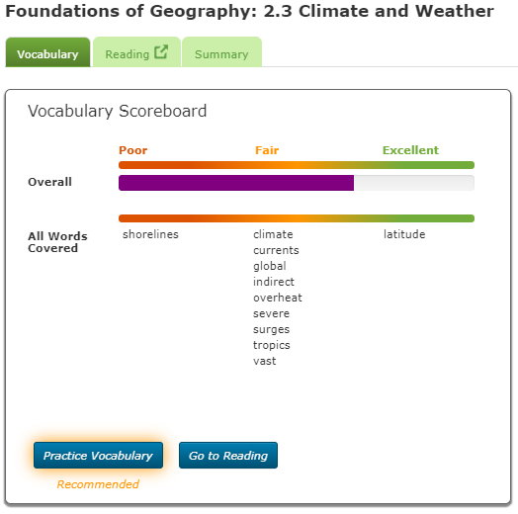
At the completion of the vocabulary exercise, the student can practice and do the exercise again, or go to the reading. The students should click on the choice they prefer or the parent or teacher recommends.
Below is a clip about from a summary activity entitled Climate and Weather. You will notice the reading on the right, which is longer than the clip shows. Notice the underlined words in blue and the blue non-underlined text near them. The underlined word, for example weather, has a link to the definition. Also, the blue text is the definition found in the selection. Also notice that climate is highlighted. If a student wishes to remember the definition of a word, in this case climate, the student can highlight the sentence and then go to the tool bar, click on the highlighter, choose the preferred color, and the sentence will be highlighted. Once the student has read the article, the student can click on the green bar on the right, Write Summary, and go to the writing activity.
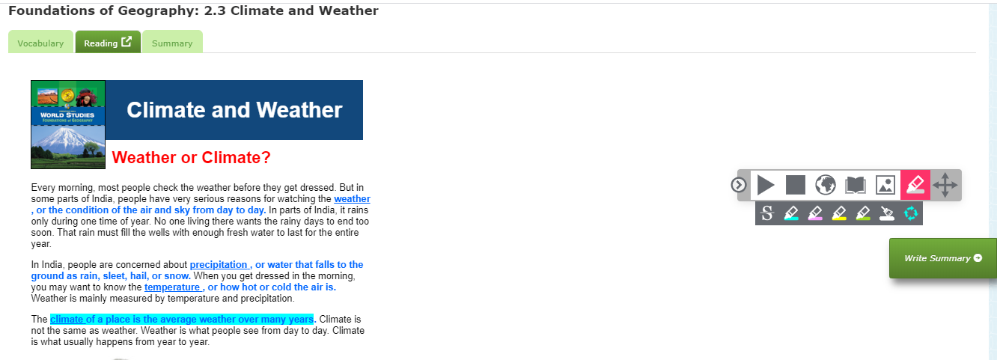
Here is a summary writing page with one try already used. Notice the alignment on the right is to the content of the article not the CCR-5 or the 6-Traits of Writing.
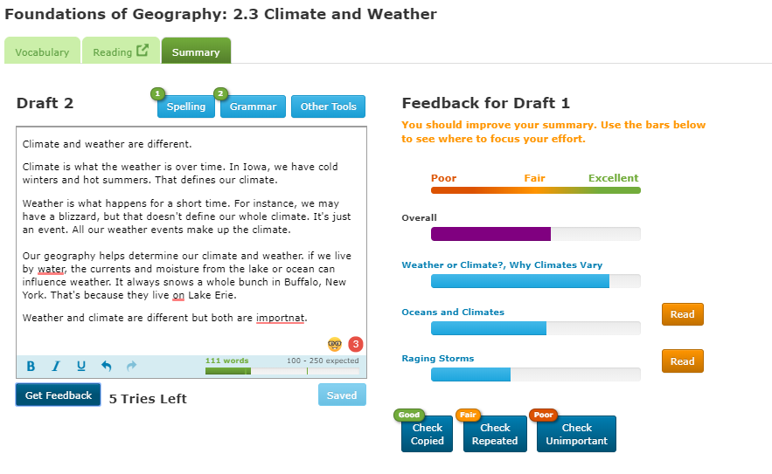

Hints
- As students write drafts, they should work to develop a strong introduction. The body of the essay should have lots of good information supporting the introduction. The conclusion should be a nice summary of what was written in the introduction and the body.
- Use the feedback behind each of the elements in essay writing to improve the writing performance. If the essay activity is aligned to the 6 Traits of writing, when the students click into the information following the elements, they will find examples of what good writing looks like, among other explanations of the elements.
- Use the feedback behind each of the sections in summary writing. Remember that you can click back and forth between the article and the summary. You don’t need to remember everything in the article. Most of the summaries are broken into parts in the article. The summary will expect students to summarize each part of the article.
- If the writer uses a lot of proper nouns in the writing, they may need to give those nouns some context. For instance instead of saying, Jennifer shot an arrow into Galveston, they might write this: Jennifer, the leader of the opposition, shot an arrow into Galveston, the city where the center of the opposition government resides.

