Directions WriteToLearn® 2021 Version, Setting Up Passwords and Logging In
Username______________________________(Your Email Address) Password ____________________
Important Links:
Teacher Login Site: https://dra-digital.com/dra3-web/login
Student Login Site: https://wtl.pearsonkt.com/student-web/login
Teachers Usernames/Passwords
Though this has not been the case previously, the new program will use your email as your username. It’s nice not to have to remember your username! You should have received a letter from this web address: dra3support@services.pearsonclinical.com. This is how you establish your password. If you have already done that and have a password, go to this website and log in: https://dra-digital.com/dra3-web/login
If you haven’t yet made your password, use the long link at the beginning of the email to go to a site to establish your password. Just put in your password twice, following the rules at the top of the page (at least 1 capital letter, at least one lower case, at least one number, and at least one symbol, and at least 7 characters long). If you find the message Invalid Token at the top left of the page, the change password option has either expired or you’ve already acquired a password. If that’s the case just go to the website: https://dra-digital.com/dra3-web/login and put in your email. Then click on Forget username/password? and create a new password. It will ask you to put it in twice. It may say you didn’t do it right, but then you eventually get an email that indicates you did! So be patient. Enter what you want slowly and carefully and then submit. And then wait for the email. Once you have done that, you will get an email saying you can log into the program. If you can’t get in, contact Pearson Customer Service at 1-800-328-5999.
This is what your login page looks like at https://dra-digital.com/dra3-web/login. Note that WriteToLearn is the program we are doing, though you don’t have to reference that when you log in. Also, note the second red underline. That’s the link for the student site. You can’t login with Google or Clever if your school hasn’t been set up. If you want it to be set up, contact your principal and ask her/him to contact Pearson Technical Support at 1-800-328-5999. I recommend that everyone be allowed to get into the program with their common password or their individual password. Thanks.
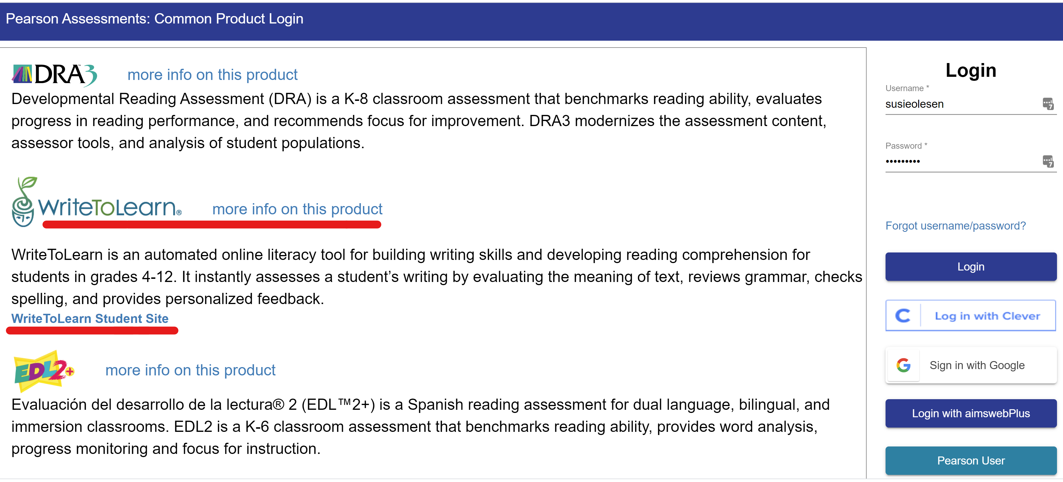

Student Usernames/Passwords
Like you, students will use their email address for their username. Below is what you must do if you want to change the individual passwords. It is easier to use the program if every student has the same password to start the year. If you haven’t done that and would like to, just contact Susie Olesen at susie@iowaschoolfinance.com . Once everyone has an account, you may wish to change the passwords so they are student specific. Below is how to do that.
When you, the teacher, log into your account, you will see icons for each one of your classes. Notice the number of students that are in the class. In this case, it’s all the 7th graders in a school, but in many cases, that number will be much smaller. Click on the blue 90 students (or whatever the number is in your class).
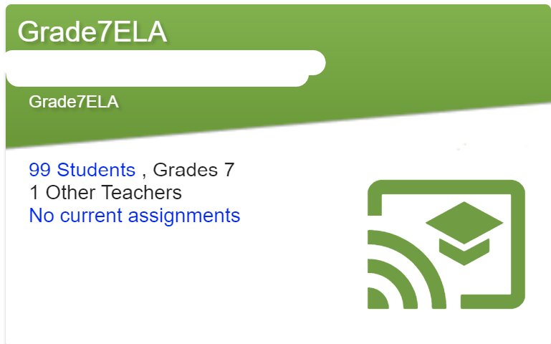
All of the students in the class will come up on the left hand side of the page. Each name is blue indicating they link to another page. When you click on each name, a pop-up will appear (see below) and there will be a Change Password link. Click on that.
Fill in the blanks with the student’s password twice. Please know that unlike previous years, because of FERPA, those passwords will not be available outside of you or the student. If you forget, you can just go in and change it again.
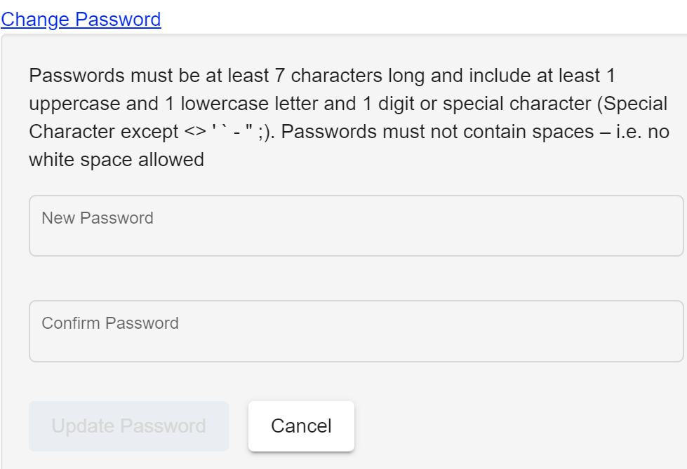
When students log in at this site, https://wtl.pearsonkt.com/student-web/login, this is what the page will look like.
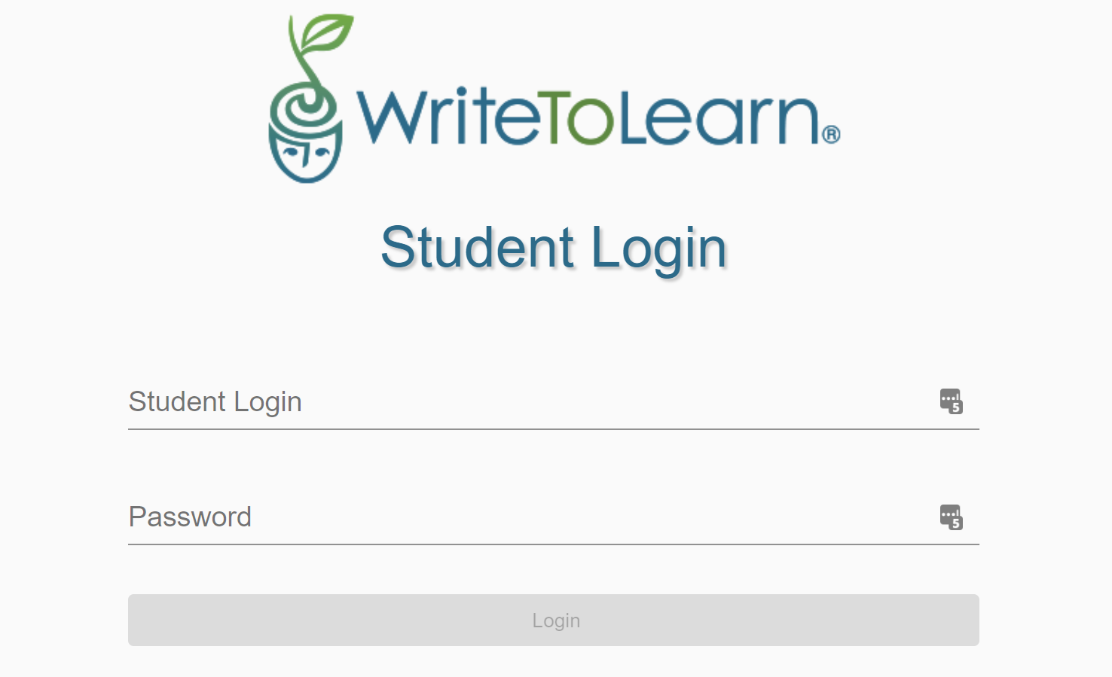
Once they login, their assignment page will appear.

