Adding a Group
Classes are made when the upload is done for the school. Groups are made by teachers or administrators who may want to separate students into smaller groups for a variety of reasons. If you want to put several students in a separate group for any reason - divide the fifth grade into homerooms, a group for low performing or high performing students, a group of students interested in animals, etc. you can make a small group and then assign different activities to them or just understand more about each class and the instructional needs they have.
- Log into your account. The top of the screen will look like this. Notice the Teacher Site in the blue ribbon across the top. Drop down and log into WTL.
- Once again, look at the top of the page at the Add Group option (underlined in red):
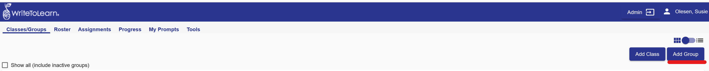
- Once you click on Add Group, this screen will come up. Name the group in the box behind the Group
Name on the left (underlined in red) and then click Add Students on the right (underlined in red).
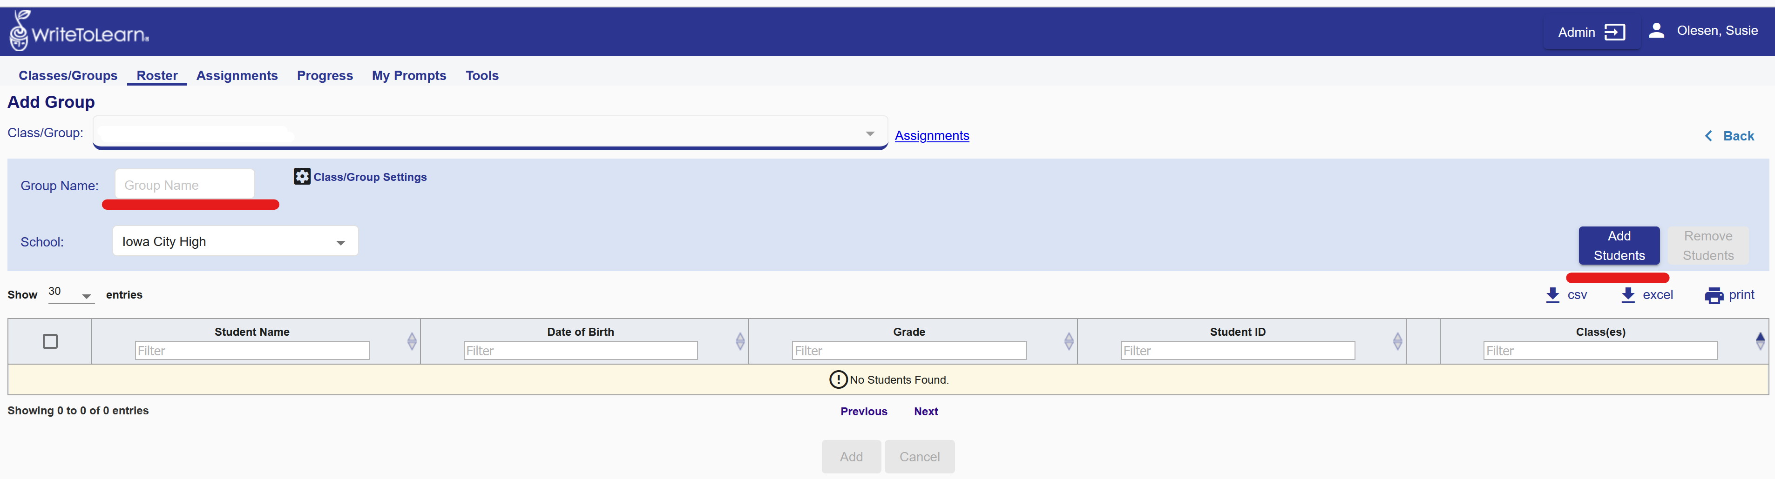
- A pop-up will appear with all the students available for you to make into a group. Notice the name appears which you entered (Bird Lovers) just to the left of the pop-up. You may have to sort by grade level to get the students you want to combine. Just click on the arrow in the topic you want to sort by, for instance “Grade” at the top of the 4th column. If you want to use all the students that show in the box, click on the top box on the left, and it will automatically select all.
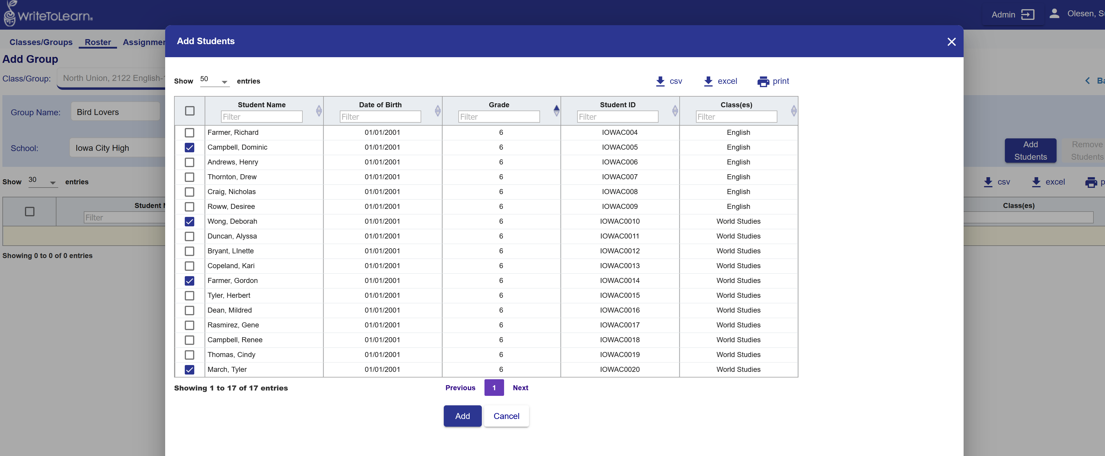

- Once you have added the students you want to be in the group, a new screen will come up with those students. If you want to add another to the group, just click again on Add Students and the process will repeat itself.
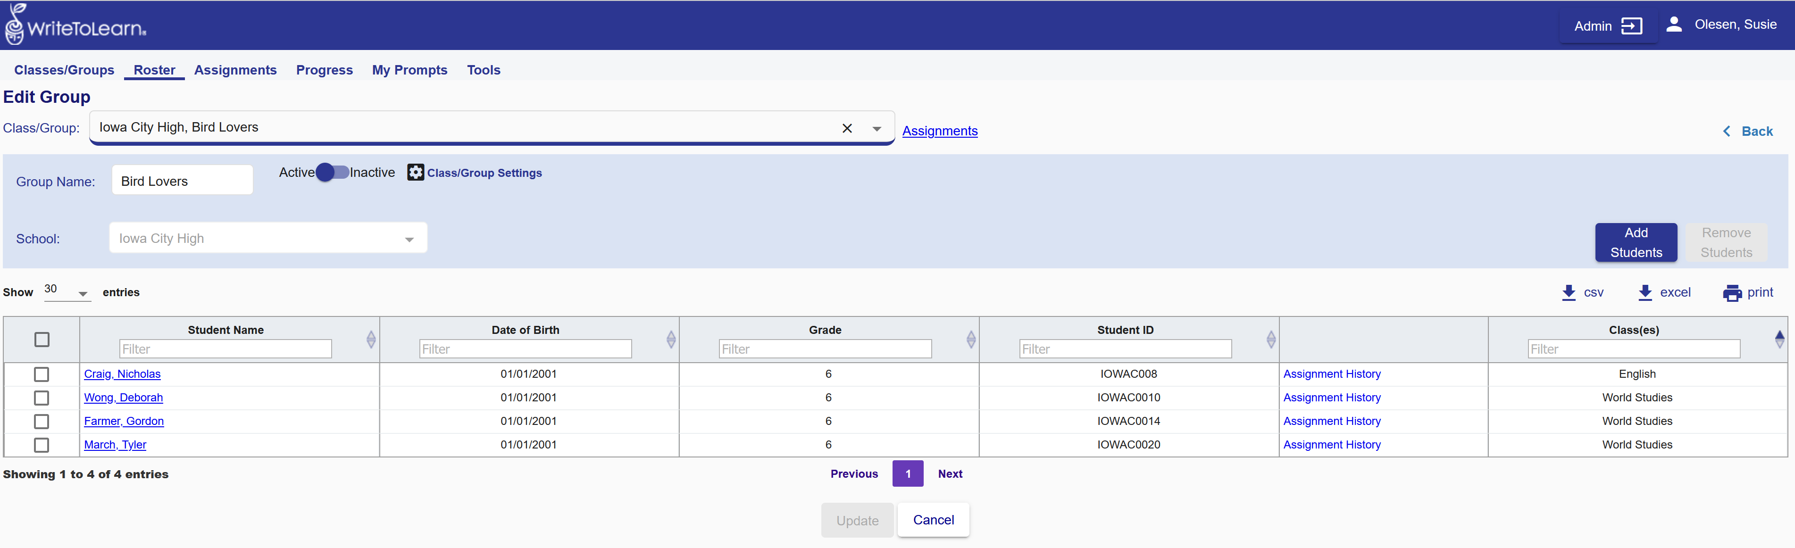
If you want to be sure the group has been added, go back to the Classes/Groups tab and check to see if there is an icon with the name you’ve chosen as a Group.

In this case there is!
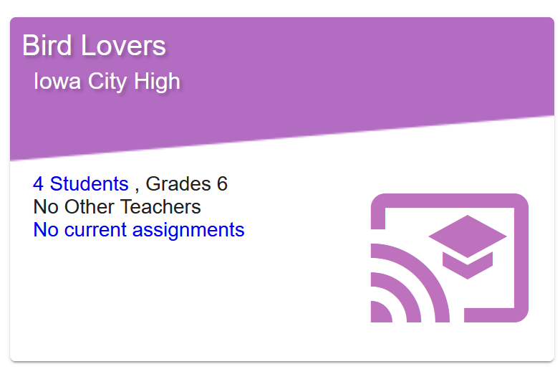

If you have any questions, contact Susie Olesen (susie@iowaschoolfinance.com).

