Technical Support for WriteToLearn®
As with all technology, occasionally something doesn’t seem to work. Technical support for WriteToLearn® is an excellent service offered by Pearson.
You are always welcome to contact Susie at ISFIS (Susie@IowaSchoolFinance.com) who can help with many issues, but sometimes your issue will need to be elevated to the technical support people at WriteToLearn®. Here is the contact info for Pearson’ WTL tech support:
- by Phone: (800) 328-5999 option 2
(hours 7am to 5pm CST)
- by Email: writetolearnsupport@pearson.com
Here is how you find this information embedded in WTL should you need it.
- At the bottom of each page (the pages you get to from the links of Classes/Groups, Roster, Assignments, Progress, My Prompts, and Tools at the top of each page) are two links, one to Contact Us (which is where the above phone number and email came from). The other is Online Support, which is where you will find directions from WriteToLearn®. Both of these are at the bottom of each page and are underlined in red below. First, click on Online Support.
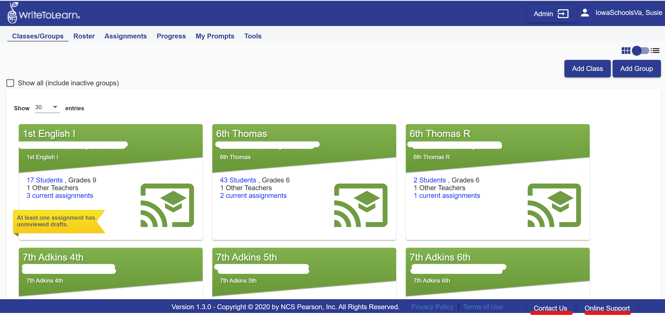

- Once you have clicked on Online Support, the screen below will come up. You will notice all the helpful information. Everything in black is a link to more information.
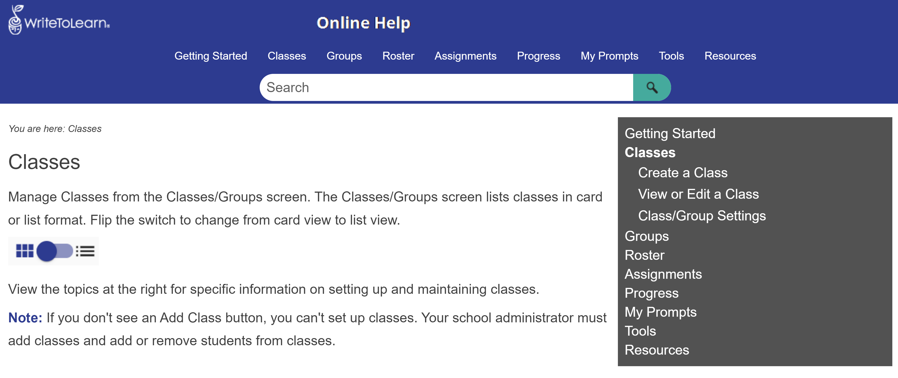
- Contact Us will show up at the bottom of all of these big links at the top of the page as mentioned previously: Classes/Groups, Roster, Assignments, Progress, My Prompts, and Tools. Contact us will NOT show up at the bottom of Online Support. Once you click on Contact Us, a pop-up will appear on your computer that looks like the screenshot below. Notice that you can call, email, or use the help report which goes directly to the help desk. All are very efficient.
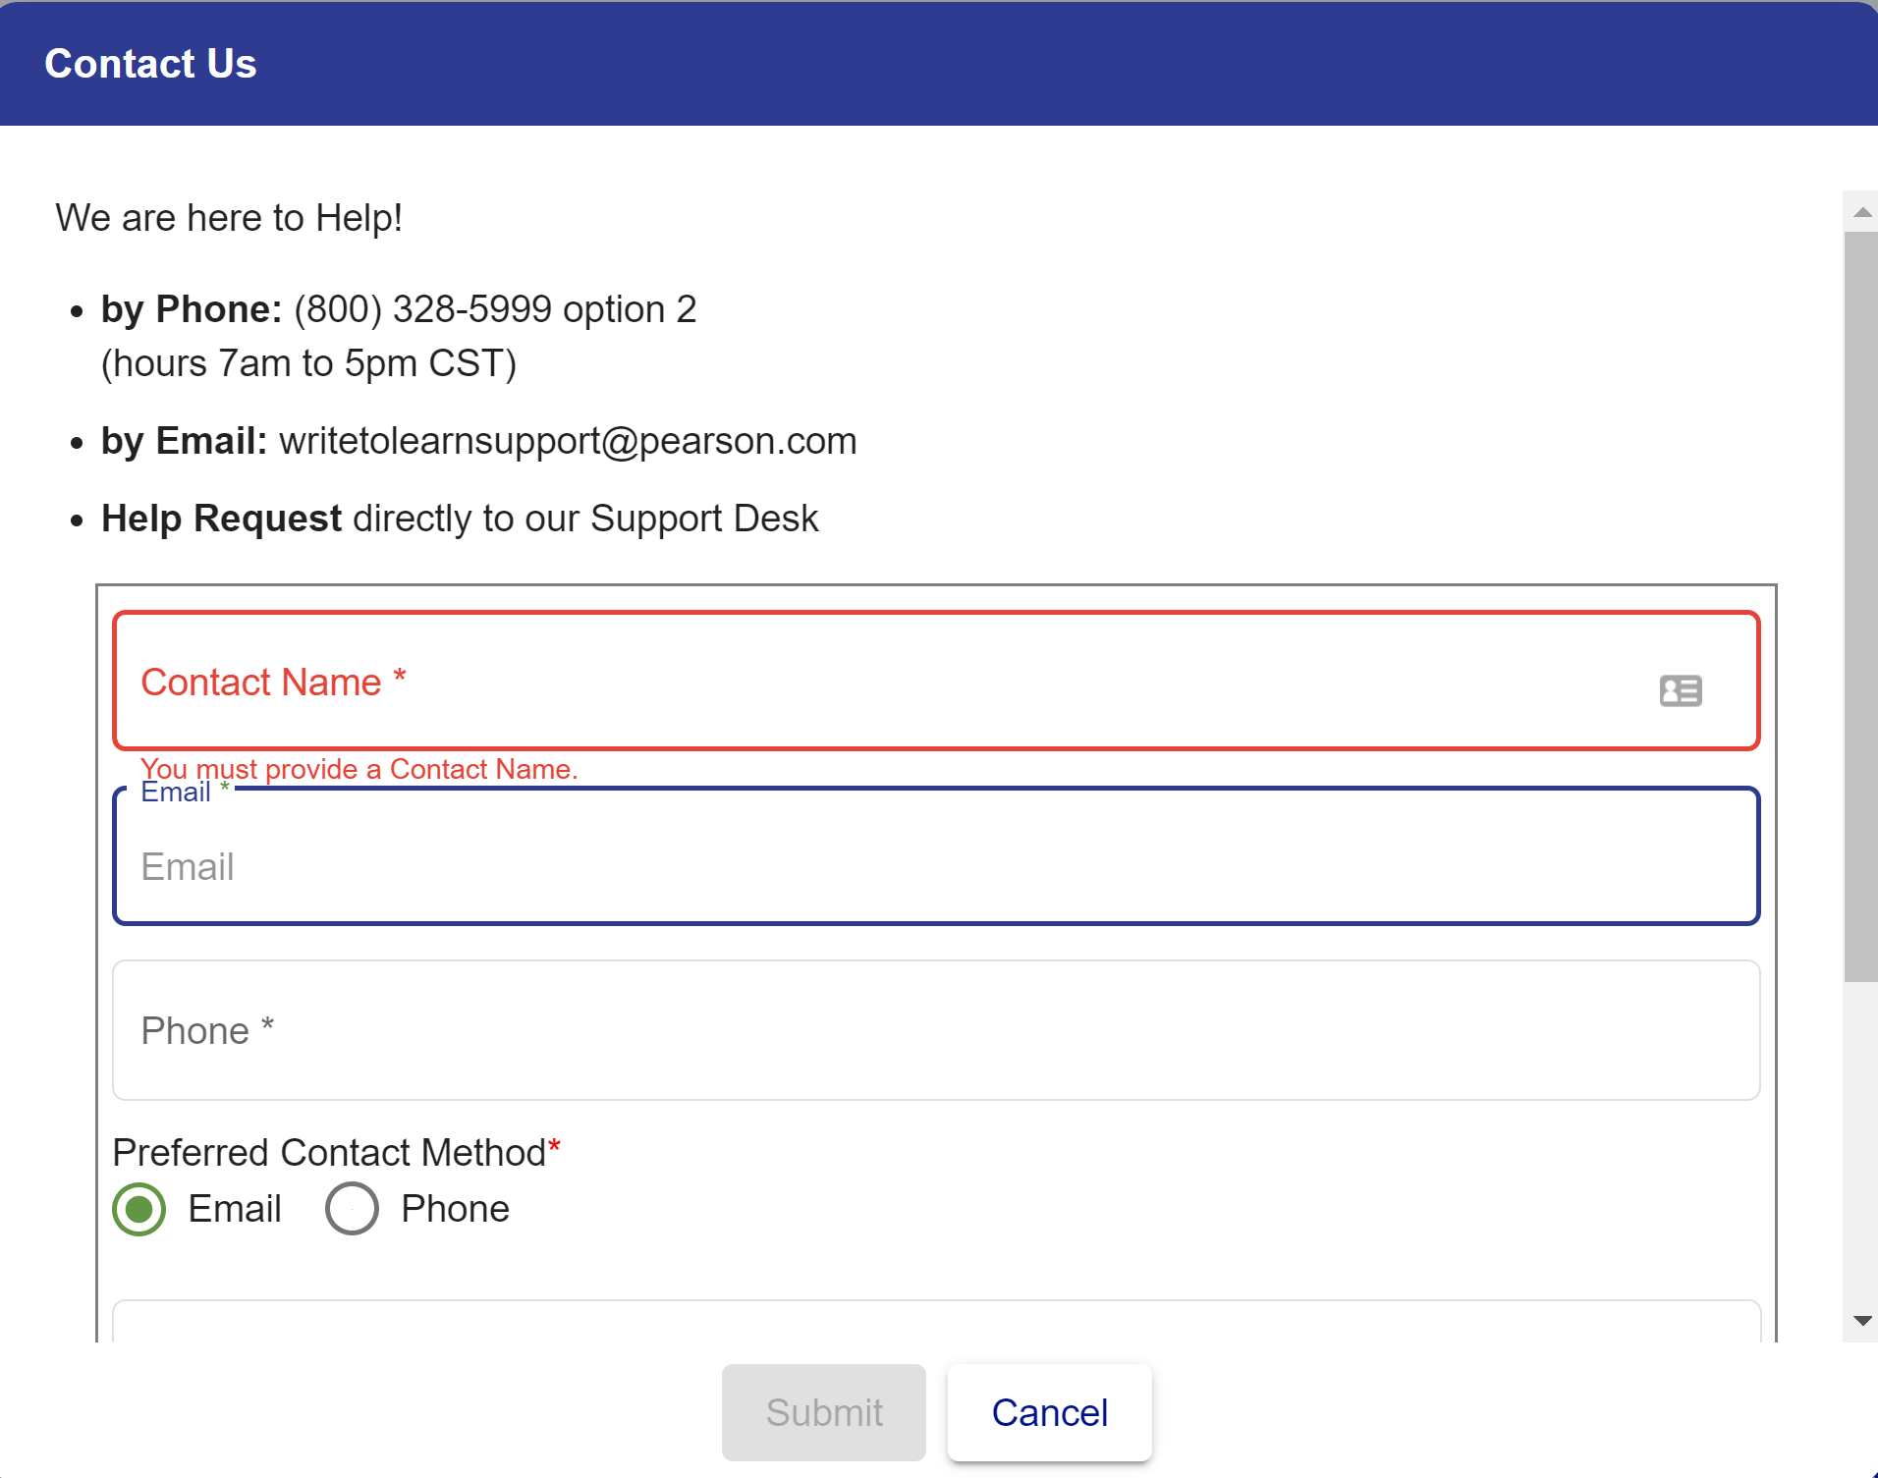
Contact Susie at ISFIS with any questions (Susie@IowaSchoolFinance.com or (641)745-5284.

